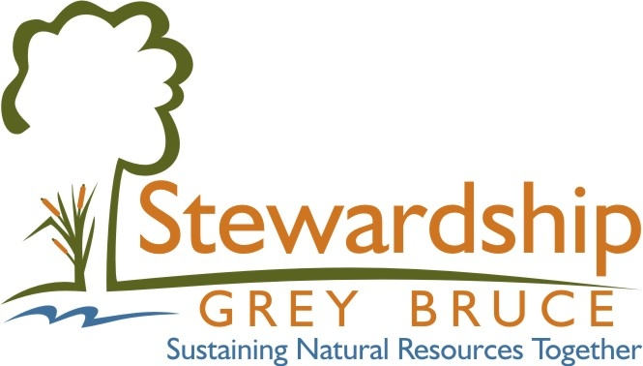

Stewardship Grey Bruce

Our goal is to create a healthy, vibrant and sustainable community through empowered citizens, natural resources stewardship, and partner collaboration.

Application Introduction

Stewardship Grey Bruce assists landowners, environmental groups and community associations in Grey and Bruce counties develop their projects.

Preferred Projects will:
• promote public awareness of our natural resources (their value, protection and management).
• establish networks of expert knowledge, technical information and sources of funding; to be available to landowners, interest groups, community associations and public and private corporations.
• foster inter-agency cooperation and shared effort
• offer educational opportunities promoting resource ecosystem sustainabilility
• set up demonstrations of sound ecosystem practices
• maintain, enhance and restore natural ecosystems

Timing: Your application must be received a minimum of ninety (90) days in advance of the commencement of the project.

Conditions for Funding:
- applicants should be prepared to submit supplier quotes that support the funding request and copies of all relevant invoices, proof of payment is required either by cancelled cheque and/or bank statements.
- Human resource or staff time wages are not funded but can be considered as In-Kind.
- labour and machinery use of the applicant, family dependants and the applicant’s business is ineligible costs but can be considered as In-Kind contribution.
- you are required to utilize funds for the stated purpose and to use the SGB name and logo on literature, media advertising, signage, etc.
- future funding will be contingent upon receipt of a final report outlining funds spent and photos of the completed work and paid invoicing.
- Note: Stewardship Grey Bruce is not to be considered as a primary source of funding. Seed money assistance in developing the project and building community involvement are available but other sources of funds and/or in-kind contributions will need to be sought and shown on the application in order to be considered by Stewardship Grey Bruce.
For further information or to submit applications, please contact:
Stewardship Grey Bruce,
P.O. Box 389,
Hanover, ON
N4N 3L9
stewardshipgreybruce@gmail.com

STEWARDSHIP GREY BRUCE Project Proposal Form

Project Title: ______________________________________________________________

Individual or Group Information:
Name: ___________________________________________________________________________
Address: ______________________________________________________________________________
_________________________________________________________Postal Code ___________________
Telephone: ___________________________ Email/Website: __________________________________
Type of Organization: i.e. Service Club, Agriculture, Fish & Game Club, etc. ______________________________________________________________________________________
# of Members: __________ Date Established: _____________
Briefly Describe Your or Your Group’s Purpose: _______________________________________________
_______________________________________________________________________________________

_______________________________________________________________________________________
Contact Person: Signature: Date:

1. Geographic Location of Project

Property Address: _____________________________________________________________________________
Town/Municipality /County _________________________________________Fire Number ________________
Lot ________ Concession ___________ Township _________ Map/ diagram attached: Yes ____
Registered Landowner consent: (must be attached ) Yes ____ Public access to site: Yes ____ No ____

2. Project Description (include: goals, intended outcomes, activities, timelines, reporting mechanisms)
________________________________________________________________________________________________________________________________________________________________________________________________________________________________________________________________________________________________________________________________________________

3. Is this a multi-year project? If so how many years and why?
________________________________________________________________________________________________________________________________________________________________________

4. Expected benefits to the ecosystem/ natural resources or community
____________________________________________________________________________________________________________________________________________________________________________________________________________________________________________________________
1 of 3
5. Project Promotion (How will the project outcomes and partners be advertised ?)
____________________________________________________________________________________________________________________________________________________________________________________________________________________________________________________________

6. This Year’s Estimated Project Total Cost
Including HST (Please indicate if you are eligible for HST rebate.)
Management Services
Paid Labour
Material and Supplies
Equipment
Other Expenditures
Total $

7. Overall Project Partners (potential & confirmed)
Name of Partner | Financial Support |  | Expected Partner Commitment
 | Cash | In-kind | Labour (hrs) | Resources | Potential/  Confirmed
(lead partner)

Totals *

8. Specific Request for STEWARDSHIP GREY BRUCE Commitment
Seed Money ($$) funds specifically requested from the SGB
SGB Time (Hrs) (will you be requesting SGB members time for your project)
Description of SGB member commitment requested.

9. Final Evaluation
To ensure everyone involved learns from the results of your group effort, you are required to provide a brief report (financial summary, photos, copies of media advertising) upon completion of the project. If the final report with proof of paid invoicing or cancelled cheques is not submitted further funding will not be approved.

2 of 3
North Map and/ or Diagram of the Site

Contact Person: ___________________________ Signature: ___________________________
Address: ________________________________________________________________________
__________________________________________________________________________________
Phone: (_____) _____________ Cell:_________________ Date: ______/________/______
Email:__________________________________

3 of 3

